Title
Brief description
Lorem Ipsum
How does it work?
Lorem Ipsum
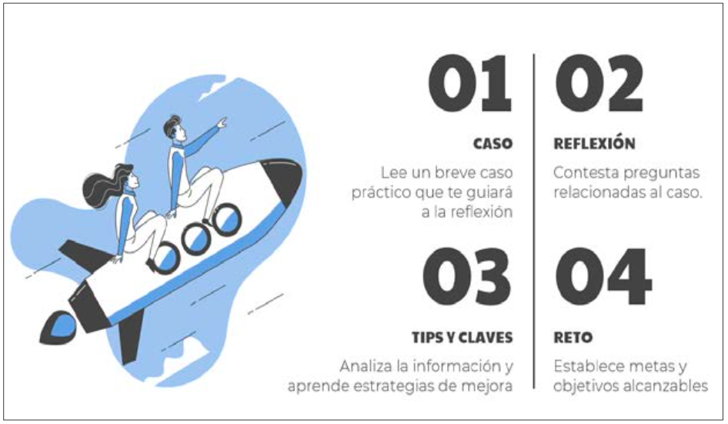
Figure 1. Píldoras ProficiencyIn+Edu en Habilmind.

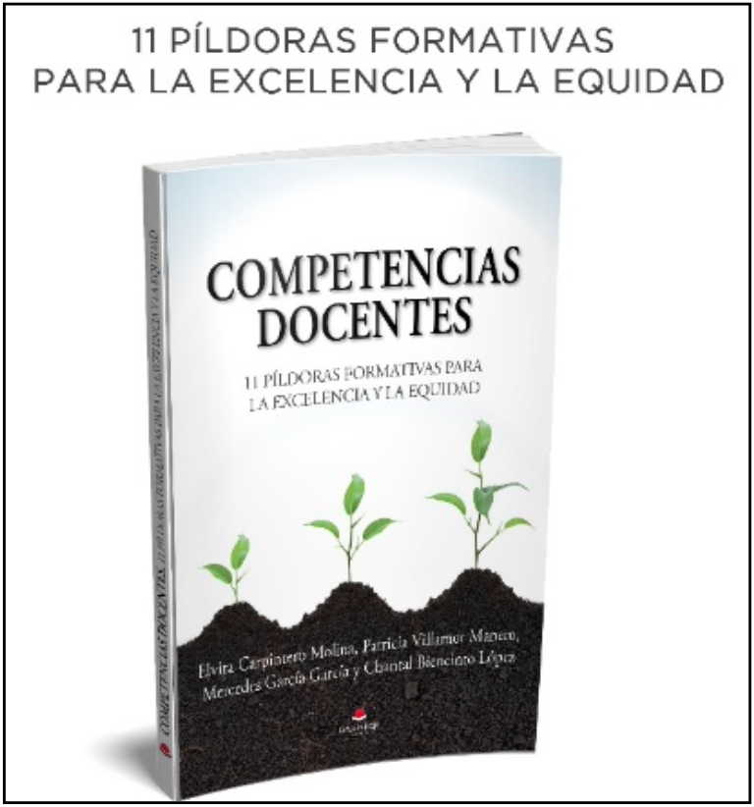
Figure 2. Libro 11 píldoras formativas
para la excelencia y la equidad.
Lorem Ipsum
What problem does it solve?
Lorem Ipsum
What future products will it develop?
Lorem Ipsum
Competitive advantages compared to other research
Lorem Ipsum
Where has it been developed?
Lorem Ipsum
And furthermore…
Lorem Ipsum
Researcher in charge
Mercedes García García, mergarci@ucm.es
Departament: Research and Psichology in Education
Faculty: Education – Teacher Training Centre

