MARÍA VALLET REGÍ
Catedrática en la Universidad Complutense y líder del grupo de Biomateriales Inteligentes (GIBI), CIBER-BBN, es académica de las reales academias de Ingeniería (RAI) y Nacional de Farmacia (RANF) y fellow de FBSE (Fellow Biomaterials Science and Engineering) y de AIMBE (American Institute for Medical and Biological Engineering). Pionera en el campo de los materiales cerámicos mesoporosos con aplicación en biomedicina, descubrió las aplicaciones biomédicas potenciales de estos materiales, particularmente en el campo de la regeneración ósea y sistemas de liberación controlada de fármacos. Es autora de más de 700 publicaciones, 13 patentes y tiene más de 44.400 citas. Ha recibido varios premios nacionales e internacionales, entre ellos el PREMIO NACIONAL de Investigación 2008, Premio JAUME I a la investigación básica 2018, el Premio Franco-Español 2000 de la Societé Française de Chimie, el Premio RSEQ 2008 en Química Inorgánica, el Premio FEIQUE de Investigación 2011, la MEDALLA DE ORO de la RSEQ 2011, IUPAC 2013 Distinguished Women in Chemistry/Chemical Engineering, el Premio de Investigación Miguel Catalán 2013, el Lilly Distinguished Career Award in Chemistry 2016 y el Premio Julio Peláez a Pioneras de las Ciencias Físicas, Químicas y Matemáticas de la Fundación Tatiana Pérez de Guzmán el Bueno 2017. En 2019 Medalla al Mérito en la Investigación y en la Educación Universitaria en su categoría de Oro, Premio ZENDAL en su 1ª Edición Internacional (2019), FEMS MATERIALS Innovation Prize2019, GEORGE WINTER Award 2019, Influentials Career Awards 2019 del Confidencial y Herbert Smith Freehills. Es doctora honoris causa por las universidades del País Vasco y Jaume I y Académica de Honor electa de la Real Academia Europea de Doctores 2019.

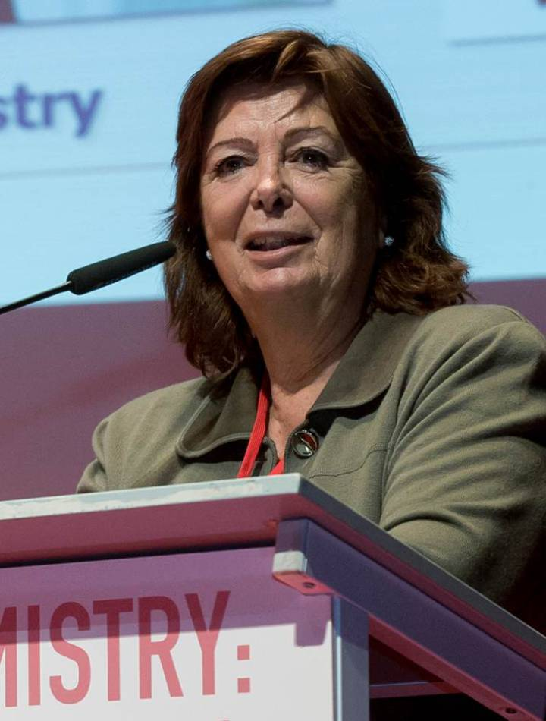
María Vallet-Regí
Full Professor
Department of Chemistry in Pharmaceutical Sciences at Universidad Complutense de Madrid (UCM), Spain
Leader of the Smart Biomaterials Research Group
Group leader of the Biomedical Research Networking centre in Bioengineering, Biomaterials and Nanomedicine (CIBER-BBN), and of the Research Institute of the Hospital 12 de Octubre (i+12), Madrid. Spain
Recipient of an ERC Advanced Grant: Polyvalent mesoporous nanosystem for bone diseases.

Contact:

Facultad de Farmacia de la Universidad Complutense de Madrid
Dpto. Química en Ciencias Farmacéuticas
Pza. Ramon y Cajal s/n
28040 Madrid – Spain

Researcher Identifiers:

ResearcherID: M-3378-2014
ORCID: 0000-0002-6104-4889
Google Scholar: http://scholar.google.es/citations?user=viPyI4EAAAAJ&hl=es&oi=ao
Highly Cited Researchers 2018

Current Research:
- Bioceramics based bone grafting materials and scaffolds for regenerative biomedicine.
- Production and study of bioceramic systems for controlled release of biotechnological and antitumoral species.
- Nanoparticles and biocompatible matrices for biotechnological applications.
- Silica based ordered mesoporous materials as release systems of biologically active species, cell encapsulation in silica porous materials, mesoporous materials for gene therapy and transfection, organic-inorganic hybrid materials.

Other interests:

- Dissemination of Science to society: more than 100 activities.
- International cooperation: numerous projects and Courses taught with Developing Countries and the free assignment of a patent for water purification.

Biographical sketch
Prof. Vallet-Regi is a recognized pioneer in the field of mesoporous ceramic materials applied to biomedicine. Her work pointed towards potential biomedical use of these materials, particularly in the field of bone tissue regeneration. Moreover, she was also a leading innovator in showing the capacity of these systems to act as “drug delivery systems”; these materials can be loaded with biological active molecules, such as drugs, peptides, proteins and growth factors, to achieve a controlled drug release of these molecules. Her first publication describing these achievements (Chem Mater 13,308-311, 2001; 2227 cites) opened a new therapeutic window, which has ended up in the launching of a novel profitable research field. This paper meant her incorporation to the 1K club of Chem Mater (I.F.=10.159), which devoted an editorial to her including sentences like: “M. Vallet-Regí and her team published in 2001 an extremely influential article which showed for the first time that MCM mesoporous materials could be used as drug delivery devices”. “The motivation behind this effort is remarkable and highlights the importance of multidisciplinary science as a source of creativity and ideas”. “This paper is a fine example of innovative and timely research, which has shaped and shaken up the field of materials science in the last few years”. In the last years, she redirected her research towards nanocarriers in stimuli-responsive systems, making converge bioceramics for bone regeneration and drug delivery, with the fight against infection. From October 2016 she obtained the five years ERC Advanced Grant: Polyvalent mesoporous nanosystem for bone diseases.
Some facts:
• >780 peer-review papers, 20 books, 38 book chapters, 12 patents.
• h-index: 99 ( 44600 Citations, Google Scholar)
• Highly Cited Researcher 2018 (Clarivate Analytics).
• Prof. Vallet-Regi´s work is characterized by interdisciplinary. Her papers classified in more than 50 Knowledge Areas of WoS
• More than 20 prestigious Awards.
• Doctor Honoris cause by the Basque Country and Jaume I Universities.
• Member of 5 Academies.
• Member of the Editorial Board of Scientific Journals and Organizer of Scientific Meetings.
• Leader of >100 R&D research projects and scientific networks.
• > 500 plenary/invited lectures in Congresses, Universities and Research Centres.
• Outstanding educator. Pioneer in Spain in the teaching of “Biomaterials”. Supervised over 30 graduation, 10 Master and 20 Ph.D. works. Her PhD students achieve relevant positions in Academy and Industry.
• Visiting Professor at INPG-Grenoble (France), NIRIM-Tsukuba (Japan), University of Stockholm (Sweden) and Cagliari University (Italy)
• Numerous institutional responsibilities and commissions of trust
• >100 activities of dissemination of science and international cooperation.
http://www.ucm.es/data/cont/media/www/pag-90171/CV.pdf
http://www.ucm.es/valletregigroup
https://vimeo.com/258578003
Highly Cited Researchers 2018
Selected Honors and Awards:
2019 Premio Influentials a la trayectoria profesional 2018. El Conficencial and Herbert Smith Freehills..

- 2019Medalla al Mérito en Investigación y Educación Universitaria. Gobierno de España. 2019.

- 2019 Premio Homenaje en la 1ª Edición de los Premios Internacionales Zendal

2019 Premio George Winter 2019.

-2019 Premio FEMS a la Innovación en Materiales 2019.
- 2018-Rei Jaume I Award in Basic Research.
- 2017-Julio Peláez Award to Pioneer Women in Sciences, Physics, Chemistry and Mathematics.
- 2016-Lilly Award to the Distinguished Career in Chemistry.
- 2015-IDEA2 2015 Award. Autonomous Community of Madrid and Massachusetts Institute of Technology Consortium.
- 2015-Doctor Honoris Causa by the Universidad Jaume I, Castellón, Spain
- 2014- GACETA DENTAL Research Award.
- 2014-Member of the International Scientific Committee of Basque Center for Materials Applications & Nanostructure.
- 2014-IDEA2 Award. Autonomous Community of Madrid and MIT Consortium.
- 2013-IUPAC Distinguished Woman in Chemistry and Chemical Engineering.
- 2013-Doctor Honoris Causa by the Basque Country University.
- 2013-Research Prize in Sciences “Miguel Catalán” of the Autonomous Community of Madrid.
- 2011-Research Prize of the Business Federation of Spanish Chemical Industries (FEIQUE).
- 2011-Gold Medal of the Spanish Royal Society of Chemistry (RSEQ).
- 2010- Evaluator of the National Research Program “Smart Materials” (NRP 62) of the Swiss National Science Foundation (SNSF) and Swiss Innovation Promotion Agency (CTI).
- 2009-2015- Advisor of the Materials for the Future Cluster. Project: “The University City of Moncloa: a Campus of International Excellence in the City of Madrid”. U.C.M.
- 2009-2017 Member of Scientific advisory board (SAB) of EXSELENT. University of Stockholm.
- 2008-National Research Prize in Engineering “Leonardo Torres Quevedo”, Education Ministry.
- 2008-Prize in Inorganic Chemistry of the Spanish Royal Society of Chemistry (RSEQ).
- 2000-French-Spanish Prize “Catalán Sabatier” of the French Chemical Society.
- 1999-2007- Spanish Royal Society of Chemistry (R.S.E.Q.) Member and Vice-president.
- 1993-2003- Member of the “Science for peace steering group” of the NATO.
Academy Membership
Since 2019-Elected Fellow of the Royal European Academy of Doctors
- Since 2017 Fellow of the American Institute for Medical and Biological Engineering (AIMBE).
- Since 2012 International College of Fellows of Biomaterials Science & Engineering (ICF-BSE)
- Since 2011 Fellow of the Spanish Royal Academy of Pharmacy (RANF), Medal XLII
- Since 2004 Fellow of the Spanish Royal Academy of Engineering (RAI), Medal LII.
- Since 1997 Elected Honorary Member of the Materials Research Society of India.
Selected institutional responsibilities:
- Member of the “Science for peace steering group” of the NATO, 1999-2003.
- Evaluator of the National Research Program “Smart Materials” (NRP 62) of the Swiss National Science Foundation (SNSF) and Swiss Innovation Promotion Agency (CTI). 2010.
- Member of Scientific advisory board (SAB) of EXSELENT. University of Stockholm. 2009...
- Advisor of the Materials for the Future Cluster. Project: “The University City of Moncloa: a Campus of International Excellence in the City of Madrid”. UCM. 2009-2015.
- Member of the International Scientific Committee of Basque Center for Materials Applications & Nanostructure 2014....
- Evaluator of the proposals for Euronanomed and more than 10 Spanish Quality Agencies
- Panel Member for the panel PE8, European Research Council (ERC) Consolidator Grant
- Spanish Royal Society of Chemistry (R.S.E.Q.) Member and Vice-president 1999 - 2007

Commissions of Trust:

- President Advisory Committee (Chemistry) of the National Commission for the evaluation of research activity (Ministry of Education), 2004-06. (Secretary, 2002-04, Board Member, 2006-09).
- Coordinator of the Technology and Health Program; Autonomous Community. 2004.
- President of the Ministry Commission of Technology of Materials, 1996 -1999
Editorships:
- 1995-2000, International Advisory Editorial Board Member of Journal of Materials Chemistry of RSC
- 2005-International Advisory Editorial Board Member of the Journal Bulletin of Materials Science.
- 2007- Editorial Board Member of The Open Inorganic Chemistry Journal (Bentham Science).
- 2007-Editorial Board Member of The Open Biomedical Engineering Journal (Bentham Science).
- 2010-Editorial Board Member of Journal of Biomaterials and Nanobiotechnology.
- 2010-Editorial Board of Bioceramics Development and Application.
- 2011-Editorial Board Member of Acta Biomaterialia.
- 2011-Honorary Advisors of Journal of Biomaterials and Tissue Engineering.
- 2012-Editorial Board Member of Journal of Ceramics.
- 2013-Editorial Board Member of Academic and Scientific Publishing.
- 2017-Editorial Board of Nanomotors for nucleic acid detection.
- 2018- Editorial Board Member of Nanomaterials.
Conference Organization:
- Chair, MINISYMPOSIUM ON BIOCERAMICS. Seminario Internacional Complutense. Madrid, Spain (1997).
- Co-chair, VIIth EUROPEAN CONFERENCE ON SOLID STATE CHEMISTRY. Madrid, Spain (1999).
- National scientific committee and chair, 17th EUROPEAN CONFERENCE ON BIOMATERIALS. Barcelona, Spain (2002).
- Chair, 1st INTERNATIONAL WORKSHOP JAPAN-SWEDEN-SPAIN. UCM, Madrid, Spain (2007).
- Coordinator, INTERNATIONAL SYMPOSIUM DRUGS, NANOMEDICENE AND BIOMATERIALS: A COMMON GOAL. Areces Fundation, Madrid, Spain (2012).
- Coordinator, INTERNATIONAL SYMPOSIUM THE CANCER AS A RESULT OF AGING: POTENTIAL SOLUTIONS. Areces Fundation Madrid, Spain (2015).
- Coordinator, SIMPOSIO INTERNACIONAL MATERIALES MESOPOROSOS: DE 1991 A 2018. Areces Fundation , Madrid, Spain (2018).
Research Facts:
Author or co-author of over 780 articles, 12 books, 6 as editor, 50 books chapters, 12 patents and >600 communications to Congresses where he taught > 50 plenary and invited lectures.

- h-index = 99 ( Google Scholar),
- Citations >44600
- Highly Cited Researcher 2018 (Clarivate Analytics)
- https://www.ucm.es/data/cont/media/www/pag-90171/List%20of%20publications.pdf

- Rank 1st of all the Professors of the University Complutense after the Bibliometric portal of University according to the h-index found un database Scopus of Elsevier (December 2018).
- Rank 55rd among the 37,819 scientists in Spanish institutions from data collected in December 2016.in ACUMEN project from European Commission 7th Framework Program, and CSIC.
- Quality of her publications: >60% of the publications in Q1 Journals (first quartile of its category), >40% in D1 Journals (first decile of its category). Moreover, several articles are top 1% by number of citations (Tables)
- Interdisciplinary of her research: WoS classifies her publications in 51 Knowledge Areas with great impact on many. Thus, based on Maria Vallet's h-index that is 98, if the h- index is calculated taking into account only its publications in each of the Areas in Isi WoS, there are very high index-h values ​​such as 63 in Materials Science (current second Spanish researcher, first for several decades), Chemistry 58, Engineering 52, Physics 50, etc.



