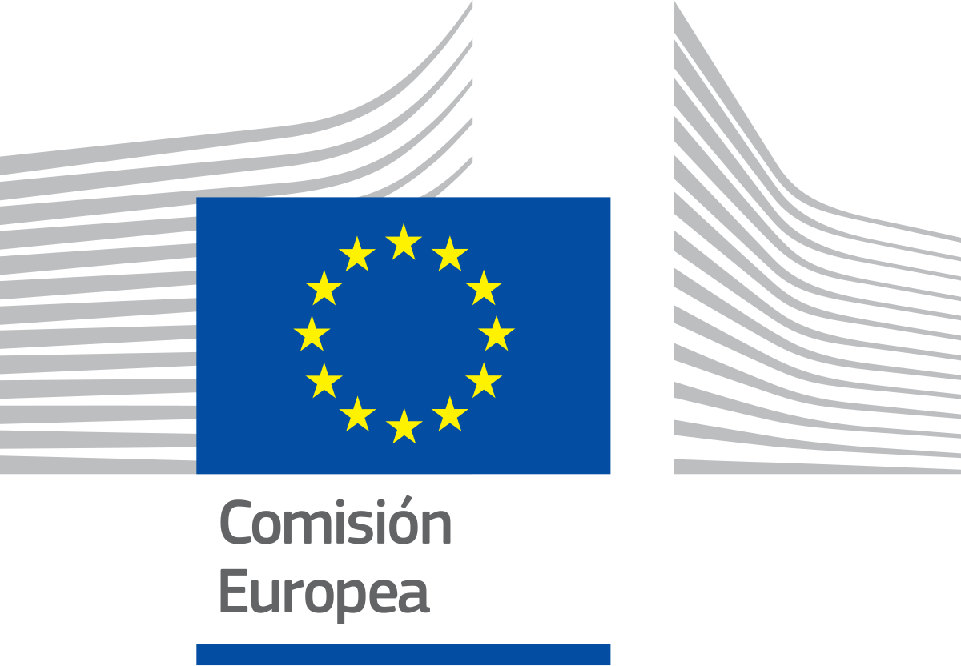
DIRECTIVE PROPOSAL

Brussels, 01/25/2025
COM (2025) 003 final 2025/0003 (COD)

Proposal of a

DIRECTIVE OF THE EUROPEAN COMMISSION

Directive (EU) 2025/0003 OF THE EUROPEAN COMMISSION

Which establishes a package of new measures applied to the field of disinformation for the promotion of truthful, accessible and quality information.

(Text relevant for EEA purposes)

THE EUROPEAN COMMISSION,

Having regard to the Treaty on the Functioning of the European Union, and in particular its Article 53(1) and Article 62,

After transmission of the draft legislative act to the national parliaments, After consultation of the Committee of the Regions,
In accordance with the ordinary legislative procedure (2), Considering the following:
- Since March 2015 with EUCO 11/15, disinformation has played a key concern in the European Union and has become a crucial issue in successive legislation and communications in this area.
- He Report of the independent High Level Expert Group on Fake News and Online Disinformation (2018) lays the foundation for understanding the impact of disinformation in democracies, while proposing measures to effectively address it.
- The Code of Good Practice on Disinformation (2018) dictates a voluntary framework for online platforms, advertisers and other actors to take concrete measures to limit the spread of disinformation.
- The previous code was replaced by the Reinforced Code of Good Practices on Disinformation (2022), which updates and expands the previous one, introducing stricter commitments for digital platforms regarding transparency and cooperation with fact checkers. The most notable difference is the establishment of mandatory measures compared to the voluntary measures of the previous one.
- He Action Plan against Disinformation presented by the European Commission in December 2018 reinforces existing tools to detect, prevent and respond to disinformation threats in the Union.
- The previous one was reinforced in the Action Plan for European Democracy (2020), which introduces measures to strengthen the resilience of European democracies against disinformation and other threats, highlighting its comprehensive vision to protect democratic processes.
- The Communication from the Commission to the European Parliament, the Council, the European Economic and Social Committee and the Committee of the Regions: Fighting online disinformation: a European approach (2018) emphasizes the need for coordinated action at the European Union level to combat disinformation campaigns that affect the stability of democratic societies.
- The Digital Services Law (Regulation 2022/2065), approved in 2022, introduces an updated regulation that addresses the responsibilities of digital platforms in the fight against the spread of illicit and disinformation content, strengthening user protection and guaranteeing transparency.

HAS ADOPTED THE FOLLOWING DIRECTIVE:

CHAPTER I

Article 1

Objective and purpose
This Directive aims, in line with priority 5 of the European Commission for the period 2024-27 on “Protecting our democracy, defending our values”, to strengthen the resilience of the democracies of the European Union against disinformation. It establishes specific measures to guarantee transparency, credibility and plurality in information ecosystems, promote digital literacy, encourage quality journalism and safeguard democratic processes against internal and external interference.

Article 2

Definitions
For the purposes of this Directive, the following shall be understood:
- Disinformation: False or misleading information created, presented and disseminated for profit or with the aim of deliberately manipulating citizens, generating negative effects on democratic processes, social cohesion, national security or democratic stability.
- Bulo: Type of disinformation consisting of false or distorted information that is generally spread deliberately with the purpose of deceiving, confusing or manipulating its recipients.
- Fake news: Hoax genre in which false or misleading content is presented as real and reliable news.
- Digital platforms: Online services that allow users to create, upload, share, disseminate or amplify digital content, including search engines, social networks, video sharing services, online marketplaces and other intermediaries that facilitate interaction or access to information between third parties.
- Data verification: Procedure of evidentiary nature intended to evaluate the authenticity, reliability and traceability of information through the analysis of verified facts and verifiable evidence.
- Fast-checkers: Set of tools, digital services, specialized equipment or procedures designed to carry out agile and effective verifications on the veracity of content, using standardized methodologies that allow obtaining results in the shortest possible time.
- Digital literacy: ability to function skillfully and intuitively in digital environments; accessing, understanding, evaluating and critically using the information obtained through them.

CHAPTER II

Article 3

Measures to implement

The measures to be implemented, in accordance with this directive, are the following:

- Establishment of a European Data Verification Agency (EAVD) dependent on the Commission to identify hoaxes and fake news, notify digital platforms of their existence and promote the rectification of such content in the shortest possible time to combat disinformation head-on, as well as publish quarterly reports on the magnitude and impact of disinformation in the EU. Likewise, it will ensure the protection of journalism and informative pluralism, guaranteeing legal protection and
security for those professionals who investigate and contribute to the reporting of hoaxes and fake news.

- This agency will be made up of 3 professionals specialized in disinformation from each Member State, who will rotate every four years in line with the renewal of the European Commission. In such a way that this system will allow the agency to adapt to the objectives established in this matter by the legislative body. It will have its headquarters in Brussels, where quarterly meetings will be held, prior to the publication of the reports.

- Member States will collaborate closely within the framework of the AEVD to generate better information quality standards, internally developing rules aimed at guaranteeing transparency regarding the financial sponsors of the different media, as well as punishing through fines all those who deliberately and systematically disseminate distorted and unverified information.

- Within the framework of the AEVD, a European Response Center to Disinformation and Cyberattacks (CERDC) will be created with the aim of strengthening cybersecurity and fighting foreign interference. It will be in charge of tracking, through a mechanism developed for this purpose, the different channels of dissemination of disinformation, as well as fake accounts and bots with the purpose of cutting these channels, thus deactivating a large part of the disinformation spreaders.

- Member States shall take the necessary measures to ensure the inclusion, in their respective educational curricula, of digital skills that promote critical thinking and the identification of fake news in virtual environments.

- Additionally, the European Commission will organize biannual awareness campaigns on the risks of disinformation aimed at segmented audiences (young people, adults, professionals) through training programs taught in all official EU languages.

- The European Commission will create a European Fund for Quality Journalism (FEPC) to finance training programs for journalists on new technologies and information verification techniques, in addition to
public social media projects and news agencies in the Member States.

- Additionally, Member States may take advantage of the FEPC to establish fiscal and economic incentives aimed at media outlets that contribute to information plurality and the fight against disinformation through the implementation of their own fast-checkers.

CHAPTER III

Article 4

Goals

- Strengthen detection and response to disinformation in the EU environment. This will be the raison d'être of the European Data Verification Agency (EAVD) through its role as identifier of fake news and hoaxes, which will considerably reduce the impact of this phenomenon in the European environment.

- Improve transparency and quality in the media and communication. To this end, the dissemination of false information will be discouraged through the imposition of fines on those Member States, media and individuals who carry out this work, which will be developed in the next chapter. In addition to the above, clear standards will be required regarding the means of financing the media.

- Promote digital literacy and critical thinking. It is behind measures such as the incorporation of tools and training against disinformation in educational curricula, in such a way that tools are provided for the identification of disinformation by citizens, combating its spread.

- Promote public awareness about the risks of disinformation, in line with the previous objective, through the biannual awareness campaigns that will be disseminated by the European Commission. This will contribute to citizens reporting disinformation, and will strengthen the democratic and social systems of the different Member States.
- Support quality journalism and information verification. Through the FEPC, different training programs will be financed for journalists and different communication agencies, as well as, from the CERDC, legal protection and security will be provided to all professionals in the field of communication who contribute to the fight against disinformation.

- Encourage information plurality and the development of verification tools. The FEPC will ensure this objective by offering fiscal and economic incentives to all Member States that believe fast-checkers to combat misinformation.

CHAPTER IV

Article 5 Sanctions

- Member States shall establish the system of sanctions applicable to any infringement of national provisions adopted pursuant to this Directive and shall take all necessary measures to ensure their implementation. In order to ensure the effective application of the provisions of national law transposing this Directive, Member States should provide for effective, proportionate and dissuasive sanctions. For such a sanctioning regime to be effective, the sanctions imposed by the national supervisory authorities should include administrative and financial sanctions, such as warnings, fines or the payment of appropriate compensation, as well as a public statement indicating the company responsible and the nature of the infringement in the event that the company does not comply within the applicable deadline with the decision imposing a financial penalty.

- Member States shall lay down, in accordance with national law and practice, rules determining appropriate measures, including sanctions, applicable to public authorities or bodies or private operators in the event of non-compliance with national provisions adopted pursuant to this Directive, and shall take all necessary measures to ensure the application of those rules.
- Member States shall ensure that sanctions established pursuant to this Article take due account of the following circumstances, as appropriate:
  - the nature, severity and extent of the violation;
  - where applicable, the intention or negligence of the infringement;
  - the population affected by the infringement, taking into account the effects of the infringement in the objective of achieving a high level of protection against disinformation.
  - the repeated or exceptional nature of the infringement;

- Any harmonization of the powers of regulatory authorities should include powers to offer incentives and impose effective, proportionate and dissuasive sanctions on companies, or to propose that a competent court impose such sanctions. In addition, regulatory authorities must have the power to request relevant information from companies, carry out appropriate and sufficient investigations and resolve disputes.

- Member States shall provide, at a minimum, for the following sanctions:
  - monetary sanctions;
- If a company fails to comply with a decision imposing a financial penalty within the established period, a public statement indicating the company responsible and the nature of the violation.

- Sanctions or accessory measures must be provided for. These sanctions or measures may include exclusion from access to public financing, including public procurement procedures, subsidies and concessions, and the withdrawal of permits and authorizations. This is understood without prejudice to the discretionary power of judges or jurisdictional bodies in the processes to impose appropriate sanctions in each specific case.

CHAPTER V

Final provisions

Article 6

Review by the Commission

No later than 5 years after entry into force, the Commission, after consulting the Member States, the social partners at Union level and the main stakeholders, and taking into account the present regulation of the directive on, where appropriate, legislative amendments.

Article 7

Entry into force

This Directive will enter into force twenty days after its publication in the Official Journal of the European Union.

Article 8

Recipients

This Directive is addressed to all Member States.

Article 9

Transposition

- Member States shall bring into force, no later than three months after the approval of the directive, the legal, regulatory and administrative provisions necessary to comply with the provisions of Articles 1 to 5. They shall immediately communicate to the Commission the textual content of these provisions.

When such provisions are adopted by Member States, they shall include a reference to this Directive or be accompanied by such a reference in their official publication. Member States shall establish the modalities of the aforementioned reference and the formulation of said reference.

- Member States shall communicate to the Commission the text of the main provisions of national law that they adopt in the field governed by this Directive.

Done at Brussels, February 3, 2025

THE COMMISSION OF THE EUROPEAN UNION

