REGISTRATION
Registration periods:
September 1, 2024- December 20, 2024
January 8, 2025 – February 1, 2025
Access from the course’s website (www…), click on “Pulse aquí para inscribirse’ (Click here to register).
On the next screen follow the instructions at the bottom that apply to you.
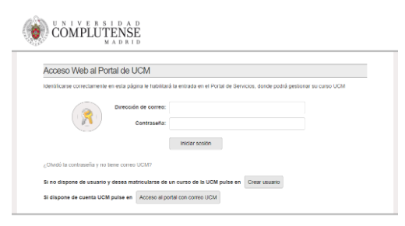
If you are within the deadline, the system will give you access to start your registration with the online self-registration application.
The online self-registration will guide you through the different blocks where you will have to enter and confirm your personal data, courses chosen and payment methods.
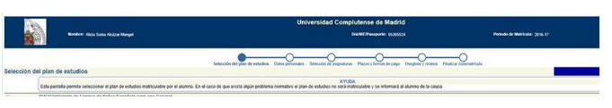
At the end of the online self-registration process, once validated, you will have obtained all the information and documentation related to your registration and payment method.
If you have any technical problem during self-registration, please contact the Master’s coordination (jarus@ucm.es).
DOCUMENTATION
Once registration has been electronically formalized or, exceptionally, within 30 days after the completion thereof, students must send the following documents to the secretariats of their centers through the the link https://documatricula.ucm.es :
a) Registration application form completed and available at www.ucm.es/matriculatp.
b) Spanish residents: DNI/NIE/TIE h t t p s : / / w w w w. u c m . e s/t a r jet a - de- ide n t idad- como -extran jero- ( tie)
or
Non-Spanish residents: PASSPORT. Only in the case of students admitted for the first time and in those cases in which the document has been modified or has expired.
c) Authorization of the holder of the account in which, if applicable, the tuition fees are to be paid by direct debit (this document will be generated through the application when the automatic registration is carried out and the account details are entered).
Students admitted to the 2024-25 academic year must present at the time of registration or, exceptionally, within 30 days after registration, all the documentation specified in the pre-registration document.
When registering, the student must present an authenticated copy or, failing that, the originals and photocopies of the photocopies of the university degree that gives access to the degree in which he/she is enrolling, and if he/she does not yet have the degree, the receipt of the original and photocopies of the university degree that gives access to the degree in which he/she is enrolling, and if he/she still does not have the degree, the receipt of the payment for its issuance (only Spanish degrees).
Likewise, if the application was conditionally admitted, the original and copy of the letter issued by the competent body of the University of origin of the degree by which it certifies that the studies carried out in the issuing country allow access to official postgraduate or Master's degrees.
The presentation of the official translation, if any, should be accompanied by the original document.
NON-EU GRADUATES PENDING DELIVERY OF DOCUMENTATION BY MEANS OF A DECLARATION OF RESPONSIBILITY:
In those cases that applicants do not have, at the time of registration, the required documentation, non-EU graduates, will sign, in the Pre-registration platform, a responsible statement in which the applicant will commit to present to the UCM's Own Degrees Section the duly legalized university degree, translated if not originally in Spanish, within the stipulated period. In this way, the registration can be made, conditioned to the final delivery of the complete documentation.
In the above cases, the Student Registrar’s Office will verify the fulfilment of the general admission requirements.
VERIFICATION OF THE DOCUMENTATION FOR ACCESS TO THE STUDIES OFFERED IN THE ONLINE MODALITY (ONLY NON-SPANISH RESIDENTS):
Student admitted to the Master’s programme must snail-mail the Philology School Student Registrar’s Office (‘Secretaría de Alumnos’) with the photocopies of the documents of access to these studies duly legalized (see section “legalizations”) in all the original documents related to the foreign degree studied. These photocopies must have been certified against the originals in the Spanish Consulate. In the case of degrees corresponding to studies carried out in European Union countries, it will suffice to provide either the originals or the photocopies certified at the Spanish Consulate.
If the documents are in a language other than Spanish, once the photocopies have been legalized and certified, they must be translated (see section “translations”) according to the corresponding agreement.
Student admitted to the Master’s programme must formalize their registration within the established period. Students have a maximum of 30 days from the formalization of their registration to provide the necessary documentation; otherwise, the registration will be cancelled.
LEGALIZATION OF FOREIGN DOCUMENTS:
All documents provided must be official and issued by the competent authorities, in accordance with the legal system of the country concerned. The procedures vary according to the country of origin of the studies, degrees or documents.
In the case of documents that must be legalized, the legalization or Apostille must appear on the original document, and therefore only the certified copy of the complete document will be valid.
OFFICIAL TRANSLATION OF FOREIGN DOCUMENTS
All documents issued in a foreign language must be accompanied by their official translation into Spanish, by means of the following:
Sworn translator/interpreter legally registered in Spain:
The official translation may be made through the Office of Sworn Interpreters of the Spanish Ministry of Foreign Affairs and Cooperation (Oficina de Intérpretes Jurados del Ministerio de Asuntos Exteriores y Cooperación Español). A list of sworn interpreters authorized in Spain for each language can be found on the Ministry's website https://www.exteriores.gob.es/es/ServiciosAlCiudadano/Paginas/Traductores-Interpretes-Jurados.aspx.
Through diplomatic channels:
The diplomatic representations of the countries of origin of the documents can translate or certify the translations. The diplomatic representation that performs or validates the translation must certify the accuracy of the translation and the content of the translation must coincide with the entirety of the original document, including the legalization procedure.
CERTIFICATION AGAINST ORIGINALS (‘COMPULSA’)
The entities authorized to certify documents abroad are the Diplomatic Representations or Consular Offices of Spain in the country issuing the diploma. The presentation of the official translation does not exempt from presenting the document that has been translated into its original language.

