Introduction to Translingual Pedagogic Design and Analysis
This handout introduces a framework for translingual pedagogic design and analysis grounded in Systemic Functional Linguistics and genre-based pedagogy, extended through translanguaging, and complemented by Legitimation Code Theory for macro-level analysis. Genre-Based Translanguaging (GT for short) is presented as a multilingual extension of Reading to Learn, where guidance through interaction around shared texts and experiences is enacted translingually through the principled use of two or more languages. Here, translanguaging refers to the purposeful and strategic use of two or more languages as integrated resources for meaning-making in teaching, learning, and participation.
The framework is organized around two complementary analytical tools:
- Translingual Teaching–Learning Exchanges for micro-level discourse-semantic analysis
- LCT Autonomy Analysis for macro-level analysis of lesson trajectories and translanguaging continua
Analytical Tool 1
Translingual Teaching Learning Exchange Structure
Reading to Learn extends the traditional Initiation-Response-Evaluation (IRE) interactional patterns into pedagogically designed sequences that scaffold successful participation. In GT, these phases function as discourse-semantic units through which language shifts are systematically organized.

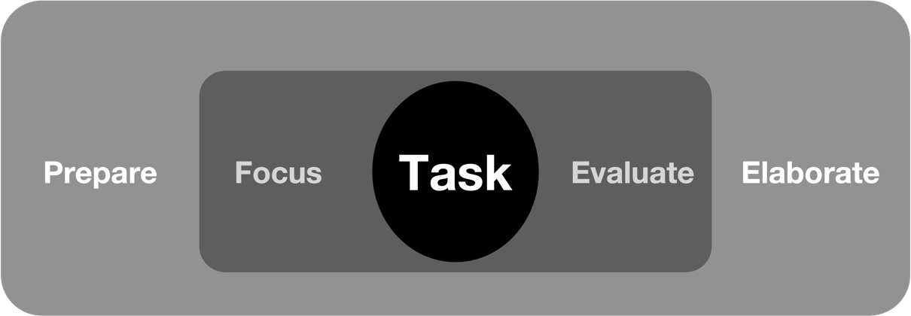
Figure 1. Nuclear and Marginal Phases in R2L Classroom Interactional Patterns
(Adapted from Rose, 2018)

Prepare and Focus guide attention to relevant meanings, enabling students to complete the Task. Responses are then affirmed through Evaluate, and extended through Elaborate to deepen understanding. Building on this interactional architecture, GT incorporates translingual options across these phases, so that language shifts become part of a principled design for guiding meaning-making across languages.
The system network below models language-shift options available during teaching–learning exchanges. Sustain options involve significant use of one language during a discourse-semantic phase, while switch options involve movement between languages for specific pedagogic purposes.
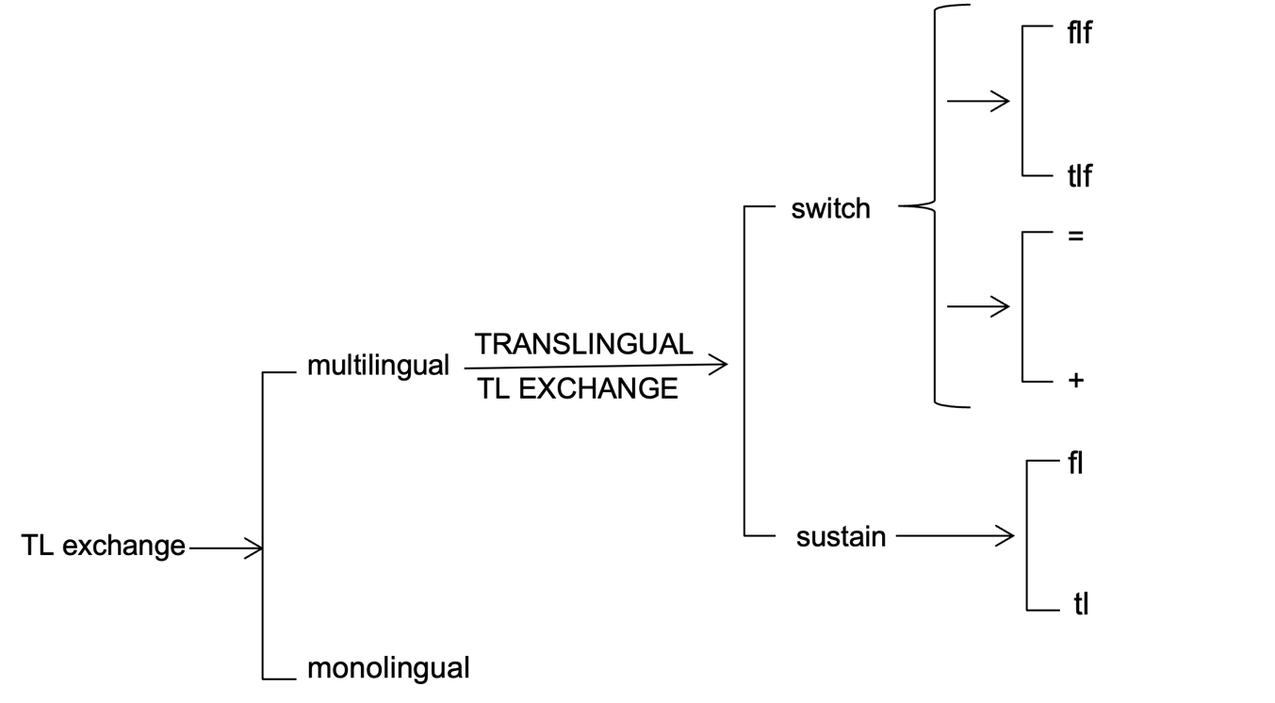
Figure 2. System Network for Translingual Teaching/Learning Exchanges
(Ramírez, in review)

The table below provides a description of each component in the system network, with examples of the two choices, Switch and Sustain. Note the difference in the switch key between the “=” option that indicates concurrent translation, and the “+” option that indicates codeswitching as opposed to just translation.

Language Option | Example | Switch Key
First with Target translation | “¿Cuál es la palabra? Which one is the word?” | F=T (translation from first)
First plus Target | “¿Cuál es la palabra? Remember to look in the first sentence. [“Which one is the word? + English] | F+T (language switch without translation)
Target with translation in First | Which one is the word? ¿Cuál es la palabra?  [English = Which one is the word] | T=F (translation from target)
Target plus First | Remember to look in the first sentence. “¿Cuál es la palabra?” [English + “Which one is the word?] | T+F (language switch without translation)
Sustain in Target | “This word is located in the first part of the sentence, and it tells us where this person lives” | T (maintains exchange in target)
Sustain in First | “Esta palabra esta al principio de la oración y nos dice que hace esta persona en este club deportivo”  [This word is located at the beginning of the sentence and tells us what this person does in that sports club]. | F (maintains exchange in first)
Table 3. Language Shift Options, Examples and Key
To illustrate even further, we will show classroom examples of the Sustain option first, followed by the Switch option.

Sustain
The sustain option refers to the continuous use of either L1 or L2 during a nuclear or marginal R2L phase. The following classroom example illustrates the sustain option in the prepare and focus marginal phases. The interaction is summarized schematically as (F ^ T ^ F), where F stands for sustain in first (during the Prepare cycle), T stands for sustain in target (also during the Prepare cycle), F stands for sustain in first again (but this time during the Focus cycle), and ^ means followed by. The interaction below should be read as “Sustain in first, followed by Sustained in target, followed by sustain in first.”
Language  exchange | Elements of cycle phase | Exchange  Role and Interaction
F ^ T ^ F
F | PREPARE Sentence Preparation | Teacher: La oración nos dice en que academia de fútbol entrena Jacobo y cual es su posición en la cancha. La voy a leer.  [the sentence tells us what soccer academy Jacobo trains in and in what position he plays. I’m going to read it].
T | PREPARE  Read Aloud | He trains in the Millonarios academy and plays as a left-back in the under 11 team.
F | FOCUS  Word position | La primera palabra está al inicio de la oración.  [the first word is at the beginning of the sentence]
Table 2. Sustain in the Prepare and Focus Marginal Phases

Switch
In the next interaction, the teacher switches between languages within the same discourse semantic unit (Core Task). This is why it is coded as a switch indicated by parenthesis. Because the switch is not a concurrent translation, it is coded as (F+T). The interaction continues with the student’s response in the target language, coded as T. The complete interaction is then coded as (F+T) ^ T, which is read as first plus target switch, followed by sustain in target. Although the interaction changed from one language to another within the same cycle element (Core), this last move is coded as a sustain move rather than a switch because it was performed by a different participant (student 1, instead of teacher).
Language  exchange | Elements of cycle phase | Exchange Role  and Interaction
(F+T) ^ T
F+T | CORE TASK  Focus | Teacher: ¿Qué es lo que el hace en la academia del Millonarios? What is that word?  [What is it that he does in the Millonarios academy? What is that word?].
T | CORE TASK  Propose | Student 1: Trains!
Table 3. Switch and sustain within the core task phase

The translingual teaching–learning exchange system network shows how classroom discourse can be deliberately designed to enable successful participation for all learners, particularly in multilingual contexts. By mapping language shift options onto the marginal and nuclear phases of Reading to Learn interactions, the framework demonstrates that language use is both systematic and pedagogically purposeful, guiding students step by step toward accurate and meaningful responses. This repeated experience of success is not only cognitively enabling but also affectively significant: it fosters confidence, strengthens learner identities as capable meaning-makers, and supports a sense of belonging in academic discourse. In this way, translingual pedagogic design aligns with insights from positive psychology, where structured success builds motivation and agency, and with sociocultural perspectives on identity formation, where participation in valued practices reshapes how learners see themselves. Thus, the system network advances translanguaging as a form of positive pedagogic discourse—one that actively constructs equity, inclusion, and empowerment through carefully scaffolded interaction.

Analytical Tool 2: LCT Autonomy Analysis
Autonomy analysis starts from a basic idea: any practice can be understood in terms of what is being used (its content) and what it is used for (its purpose). It then helps us see how these contents and purposes relate to each other across different situations.
- Positional autonomy (PA) looks at the content: What language or resource is being used? (For example, Spanish or English)
- Relational autonomy (RA) looks at the purpose: What is that language being used to do? (For example, explaining, guiding participation, or giving instructions)
In the study of translingual pedagogic discourse, Autonomy analysis can be understood as a tool for mapping how language is used across a lesson. It focuses on two key questions: (a) which language is being used at a given moment (e.g., the additional language or a shared language), and (b) what pedagogic purpose that language use serves (e.g., building participation, clarifying meaning, explaining procedures, or developing metalinguistic awareness). By tracing these patterns over time, autonomy analysis reveals recurring pathways in classroom interaction—for example, brief shifts into a shared language that support a return to sustained work in the additional language. In this way, language use becomes visible as systematic and purposeful, allowing translanguaging to be understood and developed as a principled pedagogic practice rather than as incidental deviation from monolingual norms.
The autonomy plane allows language use to be analyzed not only in terms of which language is used, but also in relation to pedagogic purpose. This makes it possible to trace systematic patterns of movement across a translanguaging continuum.
The following is the autonomy plane and the codes that it generates in each quadrant.

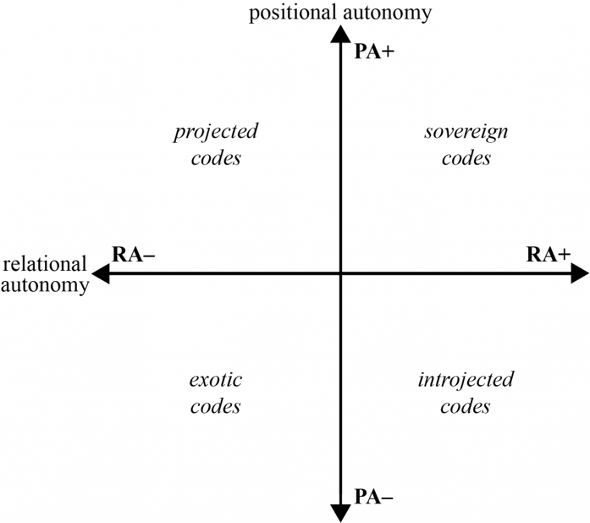

Autonomy pathways
Using these concepts, we can then trace distinctive patterns of change between these codes. These autonomy pathways (Maton 2018) reveal otherwise invisible patterns that are significant, meaningful and actionable. To begin to illustrate how the autonomy plane may function in an English-as-an-additional-language class for Spanish speakers, such as the one the focus of this presentation, consider a brief classroom moment in which the teacher uses Spanish to clarify the meaning of a key English word in a focus text. In this case, positional autonomy is relatively weaker (Spanish contents), but relational autonomy remains relatively strong because the purposes are to support comprehension of English material. On the autonomy plane, this moment (PA–, RA+) would be located in the introjected code quadrant as Spanish is used in service of English learning. The point is that such examples, identified in the autonomy plane, help visualize how language shifts can be plotted not only by language choice, but by pedagogic purpose. The graphic below shows the Autonomy plane with the codes applied to the specific study of translingual classroom discourse.

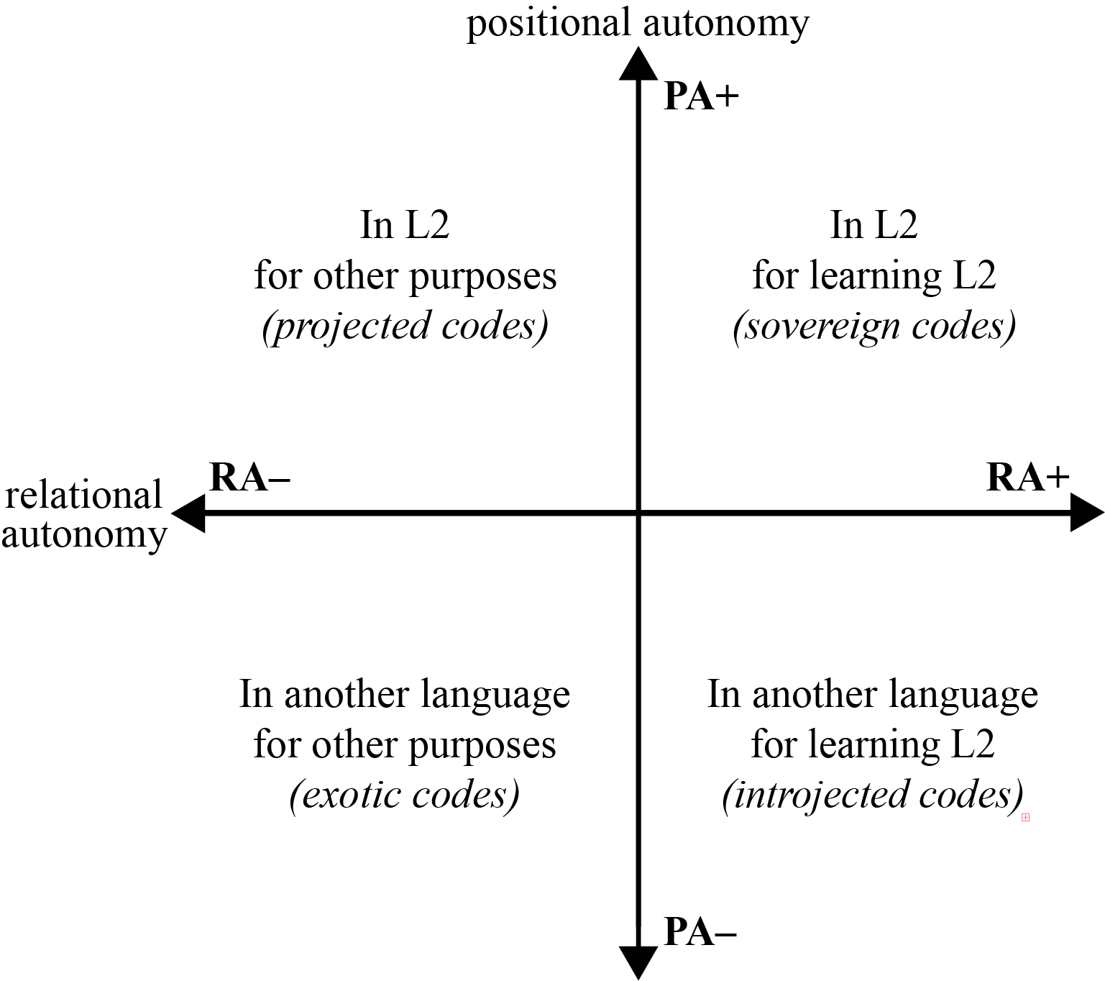
(Ramírez & Maton, in review)

Translation Devices
Translation devices operationalize autonomy analysis by linking abstract concepts, such as positional and relational autonomy, to observable classroom interactions. In translingual pedagogy, they enable systematic tracing of how language shifts relate to pedagogic purposes across lessons.

Table 4. Translation Device for positional autonomy for Illustrative Study
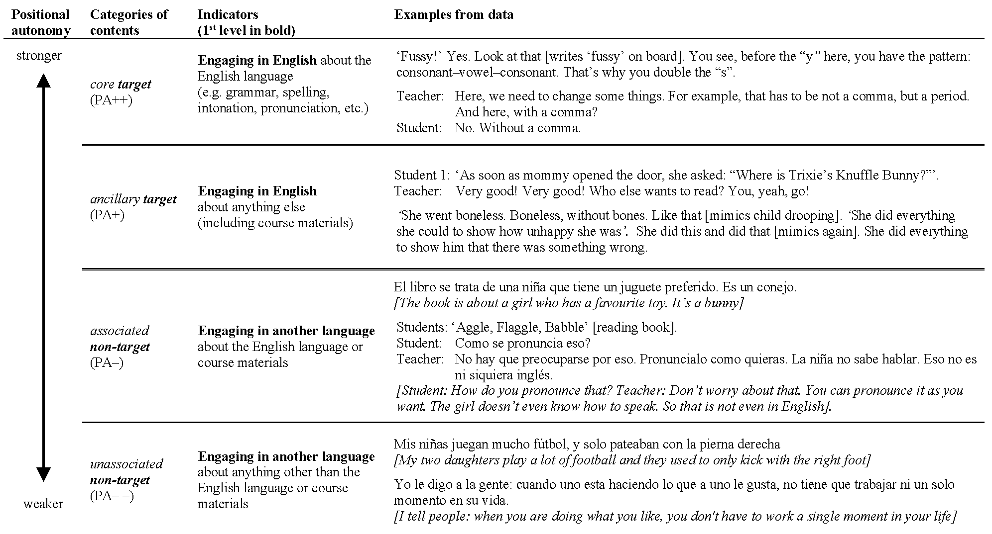

Table 5. Translation Device for relational autonomy for Illustrative Study



