MAPEO DE INSTITUCIONES Y ORGANIZACIONES DE EDUCACIÓN SUPERIOR EUROPEAS EN APOYO A LAS PERSONAS REFUGIADAS
La European University Association promueve una campaña para mostrar y documentar el compromiso de las instituciones y organizaciones de educación superior europeas para apoyar a las personas refugiadas. Aunque la campaña empieza en Europa está abierta a cualquier institución u organización en el mundo.
Algunos países como Canadá (el ejemplo de buena práctica) Noruega y EEUU, desarrollan los programas de acceso a la educación superior a través de instituciones gubernamentales.
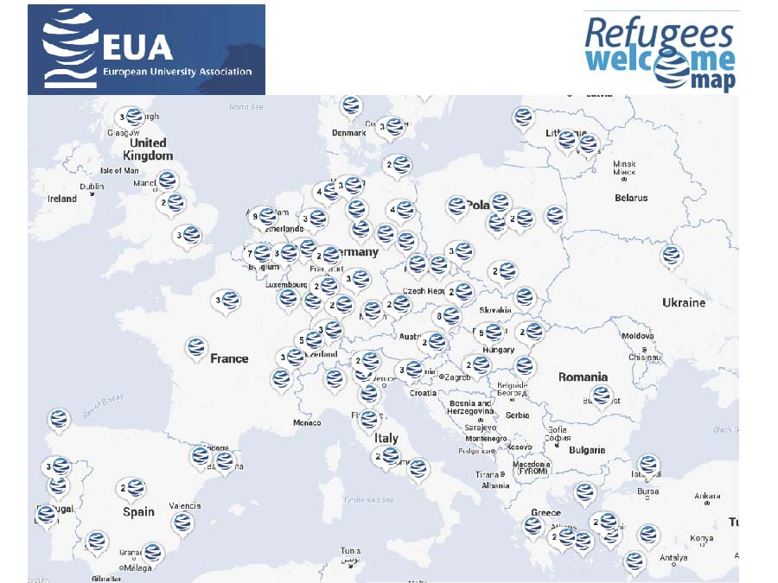

- PAÍSES, 231 participantes http://refugeeswelcomemap.eua.be/Editor/Visualizer/Index/34

Albania
- University of Lucerne
- Universität Luzern

Austria
- Centre for Social Innovation
- Zentrum für Soziale Innovation, Graz University of Technology
- Technische Universität Graz, University of Vienna
- Universität WienUniversity of Natural Resources and Life Science, Vienna
- Universität für Bodenkultur, WienUniversities, Austria
- Österreichische Universitätenkonferenz University of Music and Performing Arts Graz
- Universität für Musik und darstellende kunst GrazUniversity of Veterinary Medicine, Vienna
- Veterinärmedizinische Universität Wien
- Witschaftsuniversität Wien. University of Music and Performing Arts, Vienna
- Universität für Musik un darstellende Kunst Wien. Austrian Academy of Sciences
- Österreichische Akademie der Wissenschaften. Academy of Fine Arts, Vienna
- Akademie der bildenden Künste Wien

Belgium
- Universtité catholique de Louvain
- Vrijie Universiteit Brussel (VUB)
- Université Saint-Louis, Bruxelles
- Ghent University
- University of Mons
- Université Libre de Bruxelles
- UC Leuven-Limburg
- Université de Liège
- Universiteit Hassel
- University of Antwerp
- Université Libre de Bruxelles-Odysseus Network

Canada
- World Education Services (WES)

Czech Republic
- University of Pardubice
- Tomas Bata University in Zlín
- Charles University
- Mendel University in Brno

Denmark
- Royal Academy of Music, Aarhus
- Roskilde University

Finland
- University of Turku
- University of Eastern Finland
- University of Helsinki
- University of Vaasa
- The Student Union of the University of Turku
- University of Oulu
- European Association for International Education
- Sibelius Academy, University of Arts, Helsinki
- University of Tampere
- Finnish University Partnership for International Development (UniPID)
- Aalto University

France
- Université Paris 1 Pathéon-Sorbone
- Université de Lorraine
- Université de Strasbourg
- Université de Grenoble Alpes
- Université Paris Ouest Nanterre La Défense
- Agence Universitaire de la Francophonie
- Université de Poitiers
- Democratie & Entraide en Syrie, Ghosn Zeitoun

Germany
- German Rectors Conference
- Berlin School of Economics and Law
- Bonn-Rhein-Sieg University
- Technische Universität Dresden
- Justus Liebig University Giessen
- University of Bremen
- FernUniversität in Hagen
- Aalen University of Applied Sciences
- University of Bremen
- Open University Heidelberg
- University of Hamburg
- University of Applied Sciences
- Deggendorf Institute of Technology
- Tuebingen University
- Bamberg University
- Bard College Berlin, A Liberal Arts University
- Hamburg University of Music and Theatre
- University of Music and Trossingen
- Leuphana University of Lünenburg
- Julius Maximilian University of Würzburg
- Münster University of Applied Sciences
- RWTH Aachen University
- Friedrich Alexander University Erlangen-Nürnberg
- Kiron Open Higher Education (seminar EAIE)
- University of Siegen
- Technical University of Munich
- Leipzig University of Applied Sciences
- Aachen University of Applied Sciences
- Fachhochschule Dormund University of Applied Sciences and Arts
- Osnabrük University
- Passau University
- International Office, University of Cologne
- Heinriche-Heine University
- German Academic Exchange Service
- Philipps University Marburg
- Erns-Moritz-Arndt University of Greifswald
- University of Music and Performing Arts Mannheim
- University of Applied Sciences Nordhausen
- Stralsund University of Applied Sciences
- Weißensee Academy of Art Berlin
- Bremerhaven University of Applied Sciences
- TU Braunschweig, Bridges4Refugees
- Bielefeld University
- TH Köln
- European University Viadrina
- Ulm University
- Anhalt University of Applied Sciences
- Goethe University Frankfurt
- Europa-Universität Flensburg
- Humboldt-Universität zu Berlin
- Technische Hochschule Mittelhessen
- Kiel University
- Freie Universität Berlin

Greece
- University of Stathclyde
- University of the Aegean
- Hellenic Open University
- National and Kapodistrian University of Athens
- Harokopio University of Athens
- Hellenic Open University
- Habibi.Works

Hungary
- Central European University
- Debrecen Reformed Theological University
- Semmelweis University
- University of Pécs
- University of Debrecen
- National University of Public Service
- Central European University
- Corvinus University of Budapest

Iceland
- University of Iceland
- Háskóli Íslands

Italy
- Alma Mater Studiorum Università di Bologna
- New Research Voices
- Pavia University
- University of Trieste
- Free University of Bozen-Bolzano
- Oriental University of Naples

Lebanon
- Association of Francophone Universities A.U.F.

Lithuania
- LCC International University
- Mykolas Romeris University
- Lithuanian University of Health Sciences

Netherlands
- University of Amsterdam
- European Association of Distance Teaching Universities
- Association of universities in the Netherlands VSNU
- Technical University Delft
- VU Amsterdam
- Leiden University
- SPARK
- University of Applied Sciences Leiden
- ELIA - European League of Institutes of the Arts

Norway
- University of Oslo
- University of Agder
- MF Norwegian School of Theology
- Norwegian Agency for Quality Assurance in Education
- UiT The Arctic University of Norway
- The Norwegian University of Science and Technology-NTNU
- Hedmark University of Applied Sciences
- University of Bergen
- University College of Southeast Norway
- Norwegian University of Life Sciences
- Norwegian Agency for Quality Assurance in Education NOKUT

- Other
- New Zealand Qualifiations Authority
New Zealand Qualifiations Authority

- Poland
- Wrocław University of Technology
- Warsaw University of Life Sciences
- Poznan University of Technology
- Medical University of Warsaw
- UNIVERSITY OF APPLIED SCIENCES IN NYSA
- Lodz University of Technology
- AGH University of Science and Technology
- Pawel Wlodkowic University College in Plock
- Wroclaw University of Economics
- Jesuit University Ignatianum in Cracow
- Pope John Paul II State School of Higher Education in Biała Podlaska
Portugal
- University of Coimbra
- University of Porto
- University of Minho
- Universidade Católica Portuguesa
Rommania
- West University of Timisoara
- The National Alliance of Student Organizations in Romania

- Russia
- Ogarev Mordovia State University
- Slovakia
- Technical University of Kosice
- Slovenia
- University of Nova Gorica
- University of Ljubljana

- Spain

- University of Alicante
Universidad de Alicante

- University of Barcelona
Universitat de Barcelona

- University of Lleida
Universitat de Lleida

- UNIVERSITY CARLOS III OF MADRID
UNIVERSIDAD CARLOS III DE MADRID

- University of Sevilla

- Complutense University of Madrid
Universidad Complutense de Madrid

- High Technical School of Architecture. Universitarios of A Coruna
Escola Técnica Superior de Arquitectura. Universidade da Coruña

- University of Almeria
Universidad de Almería

- (Aunque no aparecen en el mapa, sabemos que la Universidad de Jaén y la de Santiago de Compostela han sacado becas para refugiados. La Universidad de Jaume I también estaban activando un programa desde VR Relaciones Internacionales)

- Sweden
- Linnaeus University
- University West
- University of Gothenburg
- Uppsala university
- KTH Royal Institute of Technology
- The Academy of Music in Malmö, Lund University
- Lund University
- The Swedish Council for Higher Education

- Switzerland

- University of St.Gallen
- University of Applied Sciences and Arts Western Switzerland
- University of Zurich
- University of Basel
- Swiss Federal Institute of Technology Lausanne
- National Union of Students of Switzerland VSS-UNES-USU
VSS-UNES-USU Verband der Schweizer Studierendenschaften
- University of Geneva
- University of Lausanne
- Bern University of Applied Sciences
- Turkey
- Ataturk University
- Hasan Kalyoncu University
- Koç University
- Pamukkale University

- Ukraine
- - Borys Grinchenko Kyiv University

United States of America
- Educational Credential Evaluators, Inc
- Scholars at Risk Network
- Institute of International Education
- TAICEP: The Associaton for International Credential Evaluation Professionals
- United Kingdom

- University College London
- University of Leicester
- University of Sheffield
- University of Edinburgh
- British Council
- University of Stirling
The University of Nottingham
Refugee Support Network

