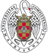
CAMPUS DE EXCELENCIA INTERNACIONAL
Departamento de Economía Aplicada II (Estructura Económica y Economía Industrial)

Portada » Departamento » Carlos Mulas Granados

Carlos Mulas Granados Click here for Spanish page
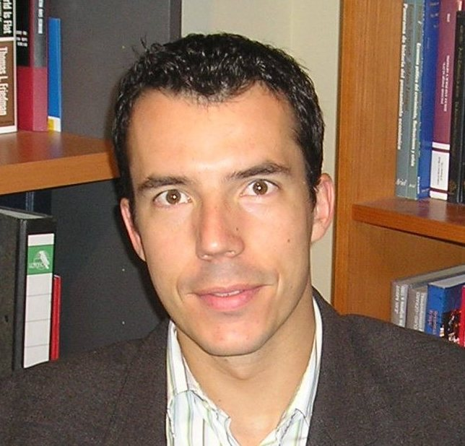 | Carlos Mulas-Granados is a tenured Assistant Professor in the Department of Applied Economics-II at Complutense University, Madrid, where he has developed his research and teaching agenda during the last decade. Currently, he works for the International Monetary Fund (IMF) and is on leave from the University.  He holds a PhD in Economics from Cambridge University (UK) and a European Doctor degree in Economics from Complutense University (Spain). He also has a Masters degree in International Political Economy from Columbia University (USA) and is Doctor Member of the Center for Advanced Studies in the Social Sciences at the Juan March Institute (Spain). Before that, he gained BA degrees in Economics and Business Administration from Carlos III University in Madrid.  He has taught and researched for national and international academic institutions. He has been a part-time lecturer at Columbia University and Cambridge University, and a full-time assistant professor at George Washington University and European University of Madrid. He has also been visiting professor in different national graduate programs at the School of Industrial Organization, the Iberoamerican Foundation of Public Policies, the Institute for Fiscal Studies and the Ortega y Gasset Foundation. He has also been a visiting scholar at the International Monetary Fund and the European Commission.  He has published extensively in prestigious academic journals such as Economic Policy, Public Choice, Research Policy, Review of Development Economics, Journal of International Money and Finance, Applied Economic Letters, International Journal of Public Policy, European Union Politics, European Political Economy Review, etc. He is also the author/editor of 3 books: El Estado Dinamizador (Editorial Complutense, 2010); Corrupción, Cohesion Social y Desarrollo en América Latina (-with Prof. J.A. Alonso- Fondo de Cultura Económica, 2011); Economics, Politics and Budgets in Europe (Palgrave-MacMillan, 2006).

RESEARCH LINES
- Public Economics
- European and International Economics

RECENT PUBLICATIONS
- “How to Cut Debt? Reassessing the Fiscal Mix for Successful Debt Reduction” (with E. Baldacci and S. Gupta), Economic Policy, Vol. 27 (71), pp: 365-406, 2012.

- “Restoring Debt Sustainability After Crisis: Implications for the Fiscal Mix” (with E. Baldacci and S. Gupta), IMF Working Paper No. 10/232, 2010.

- “How effective is Fiscal Policy Response in Systemic Banking Crises?” (with E. Baldacci and S. Gupta), IMF Working Paper No. 09/160, 2009.
- “Do budget institutions matter? Fiscal consolidation in the new EU member states” (with J. Onrubia and J. Salinas), Eastern European Economics, Vol 47 (1), pp: 61-95, 2008.

- “Reforming Government Subsidies in the New Member States of the European Union” (with T. Koranchelian and A.Segura-Ubiergo), IMF Working Paper No. 08/165, 2008.

- “The Dispersion of Technology and Income in Europe: Evaluation and Mutual Relationship Across Regions” (with I. Sanz), Research Policy, Vol 37 (5). pp: 836-848, 2007.

- “What Makes Fiscal fiscal policy sustainable? a survival analysis of fiscal consolidations in Europe” (with R. Maroto), Public Choice, Vol 134 (3-4). pp: 147-161, 2007.

- “The Phasing of Fiscal Adjustments: What Works in Emerging Market Economies?” (with E. Baldacci and S.Gupta), Review of Development Economics, Vol. 10. N. 4. pp: 612-631, 2006.

