ARTÍCULOS

Revista Internacional de Teoría e Investigación Educativa

ISSNe: xxxx-xxxx

http://dx.doi.org/

Title (13 point Times New Roman; paragraph spacing: before 24 points, after 12 points)
Author 1; Author2: … (please, do not include authorship data in the first submission)
Recibido: *** 20** / Evaluado: *** 20** / Aceptado: *** 20**
Abstract (Language of the paper. Font: 10 points Times New Roman; 12 points exactly line spacing; justify).
Keywords: (Language of the paper; 10 points Times New Roman; 12 points exactly line spacing; justify; separate with semicolon; lowercase letter),
[tr] Title translation (Use English for papers in Spanish, Italian, Portuguese or French and Spanish for papers in English; 12 pints Times New Roman; paragraph spacing: before 12 points, after 12 points
Abstract. (Same language than title translation; 10 pints Times New Roman; 12 points exactly line spacing; justify).
Keywords: (Same language than title translation; 10 points Times New Roman; 12 points exactly line spacing; justify; separate with semicolon; lowercase letter),
Summary. (1. Introduction 2. …. 5. References. 9 points Times New Roman)
Cómo citar: Author, J.J. (20**). Títle. Revista Internacional de Teoría e Investigación Educativa, ** (*), **-**. 9 points Times New Roman (please, do not include authorship data in the first submission)
1. Heading (11 points Times New Roman; bold. Numbered, starting with 1. Introduction. Paragraph spacing: before 24 points, after 12 points).
Text. ( 11 points Times New Roman; sigle line spacing; justity)
1.1. Subheading. (11 points Times New Roman; bold. Numbered. Paragraph spacing: before 14 points, after 12 points).
Figures and tables
Please, use single-space in the table body. We recommend to center the text in the cells, however, if aligning the text to the left increases readability, feel free to do it. Font: 10 points Times New Roman. Do not use vertical borders. Tables must be identified by their number in the text.
Table. 1. (10 points Times New Roman; bold; double line spacing; left alignment)
Title. (10 Times New Roman; italic; left alignment)
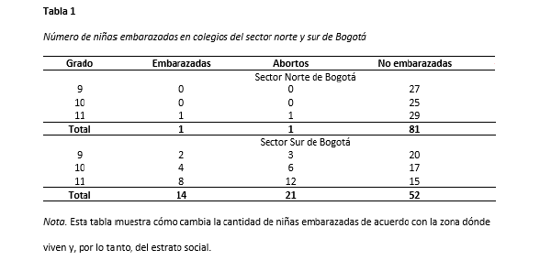
Visual elements that are not tables are considered figures in the APA style (illustrations, infographics, photographs, line or bar graphs, flowcharts, drawings, maps, etc.). Tables and figures have the same general setup.

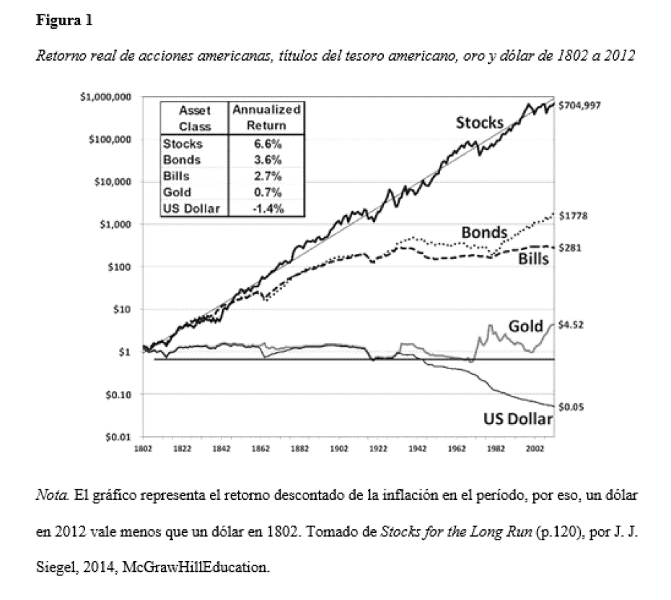
References (please, check APA 7 norms: https://apastyle.apa.org/style-grammar-guidelines/references)
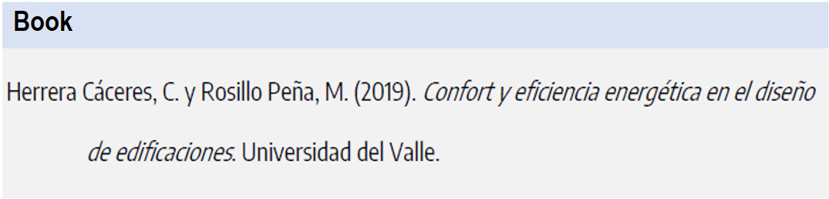

See more examples of how to reference books (book chapters, books with editor, online book, etc.) at https://apastyle.apa.org/style-grammar-guidelines/references/examples

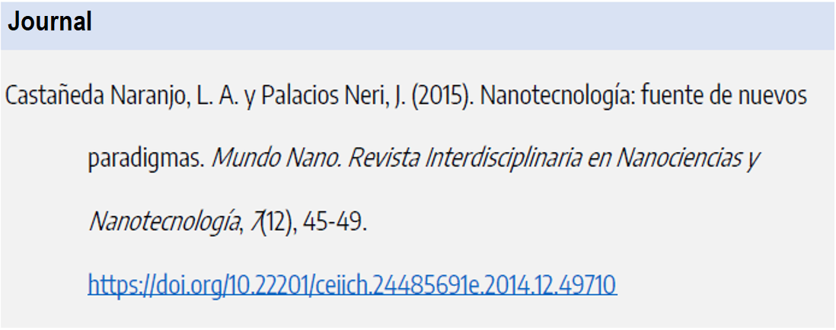

See more examples of how to reference journals at https://apastyle.apa.org/style-grammar-guidelines/references/examples

* * *

Footnotes

Footnotes and notes at the end of the text must be avoided. Only in exceptional cases will footnotes be used following this format: 8 points Times New Roman; justified; indentation 0.5.

Numerical notation

For numerical or statistical notation, APA standards must be followed. Some examples are proposed below:

- Decimals are placed with a period and not with a comma, two decimals being sufficient.
- A zero will not be used before the decimal point when the number cannot be greater than 1. This situation occurs in correlations, probabilities, significance levels, etc. For example: do not use r (24) = -0.39, p < 0.05, α = 0.78, but r (24) = -.39, p < .05, α = .78
- Any number at the beginning of a sentence is written with words and not with numerical digits.

Funding (if applicable).
Workplace (Country). E-mail: ORCID:
Workplace (Country). E-mail:. ORCID:

