In This Issue | 7 March 2016
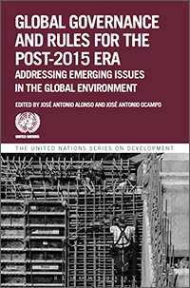 | Facebook chat on Global Governance  and the 2030 Agenda for Sustainable Development  The 2030 Agenda for Sustainable Development is a global agenda of unprecedented scope and significance. Alongside continuing development priorities such as poverty eradication, health, education and food security and nutrition, the Agenda sets out a wide range of economic, social and environmental objectives. These emerging issues and trends demand concerted responses and international efforts, which will have to be framed by new rules and more democratic and inclusive mechanisms of global governance.  Recent research by the United Nations Committee for Development Policy (CDP) presented in the publication Global Governance and Rules for the Post-2015 Era provides 1) a unique assessment of global rules and governance; 2) reflects on how global rules have been shaping development experiences and outcomes; 3) identifies the shortcomings of current global governance mechanisms; and 4) offers innovative suggestions for reforming and improving them.  On 15 March from 1:15 pm to 2:15 pm EST, Prof. José Antonio Alonso (Complutense University, Spain), Prof. José Antonio Ocampo (Columbia University, New York) and Prof. Keun Lee (Seoul National University, Republic of Korea) will be on hand to share their findings and recommendations in a Facebook live chat, offering an opportunity for those following or interested in this topic to discuss governance issues.  Post your questions at http://bit.ly/AskUNCDP or on Twitter using any of the following hashtags: #AskUNCDP #SDGs #GlobalGoals
You have received this message because you have registered or accepted our invitation to receive e-mail from DPAD. If you no longer wish to receive e-mail from us, you may wish to unsubscribe here. If you have received this e-mail from a friend and would like to subscribe to our e-mail list, click here. For enquiries or further technical assistance, please contact DPAD
Provide Feedback | Unsubscribe | Privacy Policy | Terms of Use

